Other Events

**Year 6 meeting 13.9.24 including school transition**

**Residential meeting to be confirmed**

**A showcase morning – 22.11.24**

Science

In this topic, we will enjoy completing lots of experiments.

Our first topic will be based on the topic 'Living things and their habitats'

Topic

Our topic for this term is the Victorian census for History.

Our Geography topic will be based on the question:

Why does population change

Music lessons are also taking place in Owls class until February where we will learn how to play the guitar! Otters will start this in February 2024.

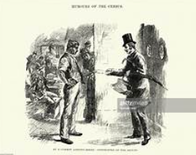

Maths

Place Value:

We will be looking at the place value of numbers up to 1 million and different ways of partitioning these numbers

Addition, Subtraction, Multiplication and Division:

 We will use formal and mental methods to add and subtract larger numbers and will then move onto multiples and factors which leads nicely into multiplication and division techniques.

Writing

In writing, we will be looking at narrative. We are completing a piece of writing based on Star of Fear, Star of Hope.

We will be focussing on using fronted adverbials, expanded noun phrases, checking that sentences are coherent and being able to use conjunctions to extend and vary sentences.

PE

In PE this half-term, we are focussing on team games.

Whilst inside, the children will be participating in ‘Tag Rugby’ team activities, focussing on communication and working as a team.

**Autumn Term**